Profile Updates – Fido Internet

Description
- Follow this procedure to update profile information, such as:
  - Billing address
  - Billing type (online/paper)
  - Contact information

Points to Mention
- This transaction can be completed by the customer on Fido.ca, under My Account.

1. Find Customer
Step | Step Details
- Login to SSP | - Email address  - Password  - Dealer Code
- Accept Customer Information Security message
- Find customer | - Enter Account number or CTN  - Postal Code  - Click SEARCH  If customer is not a wireless customer and doesn’t have their account number, click Advanced Search and search by name or address.
- Authenticate the customer with a valid government issued ID and click Continue. | Identification documents (make sure you are logged into SSP before clicking on this link)
- Under Customer Dashboard “Internet”, click View.
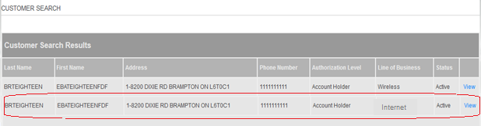

2. Find Profile Options

Step | Step Details
- Click on Profile menu. | - Account will be selected in the drop down below the account holder name. If account holder has more than one account number, select correct one.
- Under the Billing Address update icon, you will be able to select if customer would like a paper or online invoice only.  Click SAVE. | - Note that updates to the billing address will not update the service address. If the customer is moving the internet service from one physical address to another, they will need to complete a “Move Order Request” by calling Fido Care.  - For a Service Address Change, please have the customer contact Fido Care or contact EOS from the store.
- To update contact information, click on the update icon. | The following information can be updated:  - Language preference  - Mobile number  - Home phone number  - Business phone number and extension

